Faculty of Engineering and Science Research Ethics Committee

This form is intended for students studying on a taught Undergraduate or Master's Programme. Guidance notes are available at the end of the document. Students or Staff undertaking research or studying for an MSc by Research, MPhil, PhD or postdoctoral degree should use the current University Research Ethics Board form (available on the University portal).

SUPERVISORS: Please ensure you have read the complete document submitted as a single word form and remove tracked changes before signing it off and submitting it to fes-ethics@gre.ac.uk.

IMPORTANT NOTE: 1- Applications must be submitted by the deadlines shown on Moodle and circulated by email to be considered at the next available meeting. Late applications will be deferred to a later meeting.

2- An ethics application is not required for research that solely involves analysing existing secondary data.

PART A: Applicant Information and Project Basics (MANDATORY SECTION)
Applicant’s name: Giulio Dajani  University email: gd2482b@gre.ac.uk  Date of application: 06/10/2025  Anticipated start of data collection: 13/01/2026 | Programme of study: BEng (Hons) Software Engineering  Department / School / Institute: CMS  Supervisor’s name: Razia Sulthana Abdul Kareem  University email: razia.sulthana@greenwich.ac.uk
- Project title:

Reel or Real? A Context-Aware Deepfake Detection and Verification Framework

- State the aim of the project and the data collection method(s) you intend to use:

This project aims to develop and assess a lightweight software framework for detecting and verifying deepfake content in images and videos. The project concentrates on creating a modular detection system and evaluating its performance using a mix of real participant-provided videos and established academic deepfake datasets (e.g., FaceForensics++, DFDC, Celeb-DF).

Participants (aged 18+) will be invited to upload a short video of themselves only (5-10 seconds, recorded beforehand on their phone). These videos will function as “real” reference samples to evaluate the system’s ability to distinguish genuine human-recorded videos from deepfake videos in established datasets.

No deepfakes will be created of participants, and no external videos (e.g., from social media) will be used. Participants will then complete a short online questionnaire about usability and perceived accuracy. All personal video data will be securely stored on University OneDrive and deleted permanently at the end of the project.

- How many participants do you expect to take part in your study, and how do you intend to recruit them?

Expecting 350–400 adult participants.
Recruitment will be via:
- Personal networks (non-vulnerable, over 18 years old).
- Social-media posts with a participant information sheet attached.
- YCIT (China) and UniTo (Italy) Universities.

- Where will this research be undertaken (location, place, country and/or online)?

The research will be conducted online, using a prototype web interface hosted by the University of Greenwich and Microsoft Forms for surveys. No in-person data collection is planned.

PART B: Application Details (MANDATORY SECTION)
- Criteria |  | YES or NO
Does your work require the participation of humans? |  | YES
Are you using a university-approved online survey/interview platform to collect data? (e.g. Microsoft Forms, Mentimeter, OnlineSurveys) |  | YES
Is a university-approved platform the only method of data collection you will be using when interacting with humans? |  | YES
Will you manage informed consent using the consent form template below? |  | YES
Will you manage informed consent using the template participant information sheet (PIS) template below? |  | YES
Will you interact only with people who are not vulnerable? |  | YES
Will you interact only with people over 18 years old? |  | YES
Will you ensure that you do not coerce or deceive your participants? |  | YES
Will you explain to participants their right to withdraw from the PIS, including when and how they can do this? |  | YES
Will you exclude all personal (non-university) information, such as mobile phone numbers and work email addresses, from the Participant Information Sheet (PIS) and consent form? |  | YES
Will you store the data you generate securely using the university OneDrive? |  | YES
Will you destroy all the data associated with this project securely after the project is complete? |  | YES
If all of the above answers are ‘YES’, complete PART A, PART B, and PART D, attach the required documents (templates are provided), and have your supervisor return the application to:
FES-Ethics@gre.ac.uk once both of you have signed and dated the declaration in PART D, confirming that you have read and endorse the application. If any answer is ‘NO’, please continue to PART C.

PART C: Project Details
- If this research is being undertaken outside the University do you have written confirmation from the establishments involved? If YES, please attach to this form. |  | Choose an item.
- Has this research previously been approved by UREB? If YES, list Principal Investigator, date and UREB number. |  | Choose an item.
- Risk Assessment |  | YES or NO
Is a risk assessment required? |  | Choose an item.
Has a risk assessment been submitted and approved? |  | Choose an item.
- Does your research involve any of the following common ethical issues? (Answer all, please)
Participant Selection YES or NO
The use of vulnerable populations (addiction, mental illness, and aged subjects)? |  | Choose an item.
Involvement of children under 18? |  | Choose an item.
Involvement of children under 16? |  | Choose an item.
Data Collection Methods YES or NO
Use of finger-prick blood sampling? |  | Choose an item.
Venous blood sampling? |  | Choose an item.
Ingestion of material (food /supplements)? |  | Choose an item.
The involvement of any other physical contact not listed above? |  | Choose an item.
Use of a validated published questionnaire (including a pre-health screening questionnaire)? |  | Choose an item.
Use of a questionnaire previously approved by FREC or UREB? |  | Choose an item.
Use of a new/adapted questionnaire or semi-structured interview checklist? |  | Choose an item.
Are you collecting sensitive personal data such as sexuality, criminal offences, etc? |  | Choose an item.
Will volunteers be collecting data on your behalf? |  | Choose an item.
Participant Issues YES or NO
Will participants face humiliation or psychological stress as a result of the study? |  | Choose an item.
Are you planning to use coercion or incentives? |  | Choose an item.
Are you planning to use deception? |  | Choose an item.
Will your results affect the participants’ standing at University, work or in society more generally? |  | Choose an item.
Do you intend to photograph, video or audio record your participants? |  | Choose an item.
- How will you manage the ethical issues, including those identified in PART A and PART C? Your response should address informed consent and the right to withdraw.

- How will you manage and ensure participant confidentiality?

12. How will you manage the collection, storage and disposal of tissues as regulated by the Human Tissue Act (2004)

PART D: Declaration and Attachments (MANDATORY SECTION)
Attachments |  |  | YES or NO
Participant consent form(s) (MANDATORY) |  |  | YES
Participant information sheet (MANDATORY) |  |  | YES
Questionnaires/semi-structured interview checklist (MANDATORY) |  |  | YES
Advert/recruitment poster/invitation to participate email, etc. (MANDATORY) |  |  | YES
Photographic, video & audio consent form |  |  | YES
Approval from an external establishment |  |  | NO
Volunteer (Enumerator) information & consent form.  (Available from the FREC Moodle page) |  |  | NO
Applicant’s name: GIULIO DAJANI | Signature: | Date: 21/11/2025
Supervisor’s name: RAZIA SULTHANA ABDUL KAREEM | Signature: | Date:
Safety officer’s name (if risk assessment required): | Signature: | Date:

UNIVERSITY of GREENWICH
Faculty of Engineering & Science

PARTICIPANT CONSENT FORM
Title of Project: Reel or Real? A Context-Aware Deepfake Detection and Verification Framework
Name of Researcher: Giulio Dajani

To be completed by the participant.

- I have read the information sheet about this study.
- I have had an opportunity to ask questions and discuss this study.
- I have received satisfactory answers to all my questions.
- I have received enough information about this study.
- I understand that I am / the participant is free to withdraw from this study:
  - At any time (until such date as this will no longer be possible, which I have been told)
  - Without giving a reason for withdrawing
  - (If I am / the participant is, or intends to become, a student at the University of Greenwich) without affecting my / the participant’s future with the University
- I understand that my research data may be used for a further project in anonymous form, but I can opt out of this if I so wish, by ticking here. o
- I agree to take part in this study o
- I am over 18 years old o

Signed (participant): | Date:
Participant name in block letters:

Signature of researcher: | Date: 21/11/25
This project is supervised by (including University e-mail address):
Razia Sulthana Abdul Kareem, razia.sulthana@greenwich.ac.uk

Researcher’s contact details (including University e-mail address):
Giulio Dajani, gd2482b@gre.ac.uk

UNIVERSITY of GREENWICH
Faculty of Engineering & Science

PARTICIPANT INFORMATION SHEET
(Participants over the age of 18)

Dear Participant,

My name is Giulio Dajani and I am currently studying at the University of Greenwich for my degree in BEng (Hons) Software Engineering. As part of my studies, I am undertaking a research study entitled Reel or Real? A Context-Aware Deepfake Detection and Verification Framework.

Invitation
I would like to invite you to take part in this research study. Before you decide to allow this, you need to understand why the research is being done and what it would involve for you. Please take time to read the following information carefully. If anything you read is not clear or you would like more information, please do not hesitate to contact me.

What will happen if you take part?
This study explores how people understand and experience Deepfakes—AI-generated videos or images—and how they perceive the trustworthiness of online media.
If you agree to take part, you will complete a short online questionnaire (13–15 questions, about 2 minutes) on your awareness and opinions of Deepfakes. At the end, you will have the option to upload a short video and a few clear facial images of yourself to support research dataset creation.
All responses and any uploaded media will be confidential and anonymous, accessible only to the researcher and supervisor. You may withdraw at any time before submission, but once submitted, anonymised data cannot be withdrawn. All data will be securely deleted after the study
What about confidentiality?
Digital data will be anonymised wherever possible, stored on an encrypted disk and kept in a locked cupboard for the duration of the study; non-digital data will be stored in a locked box, in a locked cupboard. Data will only be accessed by the researchers, students and staff members directly involved in the study and data that can be used to identify individuals will not be made public without the express written informed consent of the individual being identified. Once the study has been completed (and any archiving responsibilities undertaken), the data will be shredded (non-digital and CD/DVD media) or deleted and overwritten (for re-writeable digital media).
Who to reach in case of queries or concerns.
In case of any queries or concerns, feel free to reach out Giulio Dajani through their university email address gd2482b@gre.ac.uk. Alternatively, you can do this through the research supervisor Razia Sulthana Abdul Kareem at the Faculty of Engineering & Science, who can be reached via their university email razia.sulthana@greenwich.ac.uk.

Indicative questions

Please provide up to 13 example questions that will be used in the study.

- Have you ever heard the term “Deepfake” before?
☐ Yes ☐ No ☐ Unsure
- How confident are you that you understand what a Deepfake is?
☐ Not at all ☐ A little ☐ Moderately ☐ Very well
- Where did you first learn about Deepfakes? (Select all that apply)
☐ Social media (e.g. TikTok, Instagram, YouTube)
☐ News articles or TV reports
☐ Friends / family
☐ Other (please specify) ___________
- Have you personally encountered any Deepfake videos or images online?
☐ Yes ☐ No ☐ Unsure
- If Yes, where did you most often see them?
☐ Social media feed ☐ Messaging apps ☐ News sites ☐ Entertainment content ☐ Other_________
- How often do you think you are exposed to manipulated media online?
☐ Never ☐ Rarely ☐ Sometimes ☐ Frequently ☐ Almost daily
- Would you be willing to contribute a short, authentic video and a few facial images of yourself to support Deepfake detection research?
☐ Yes, I consent to provide media files under the terms described in the Participant Information Sheet.
☐ No, I do not wish to contribute media.

Draft Invitation Email

Please provide a draft invitation, either as an email or message, to be sent to potential participants for your study.
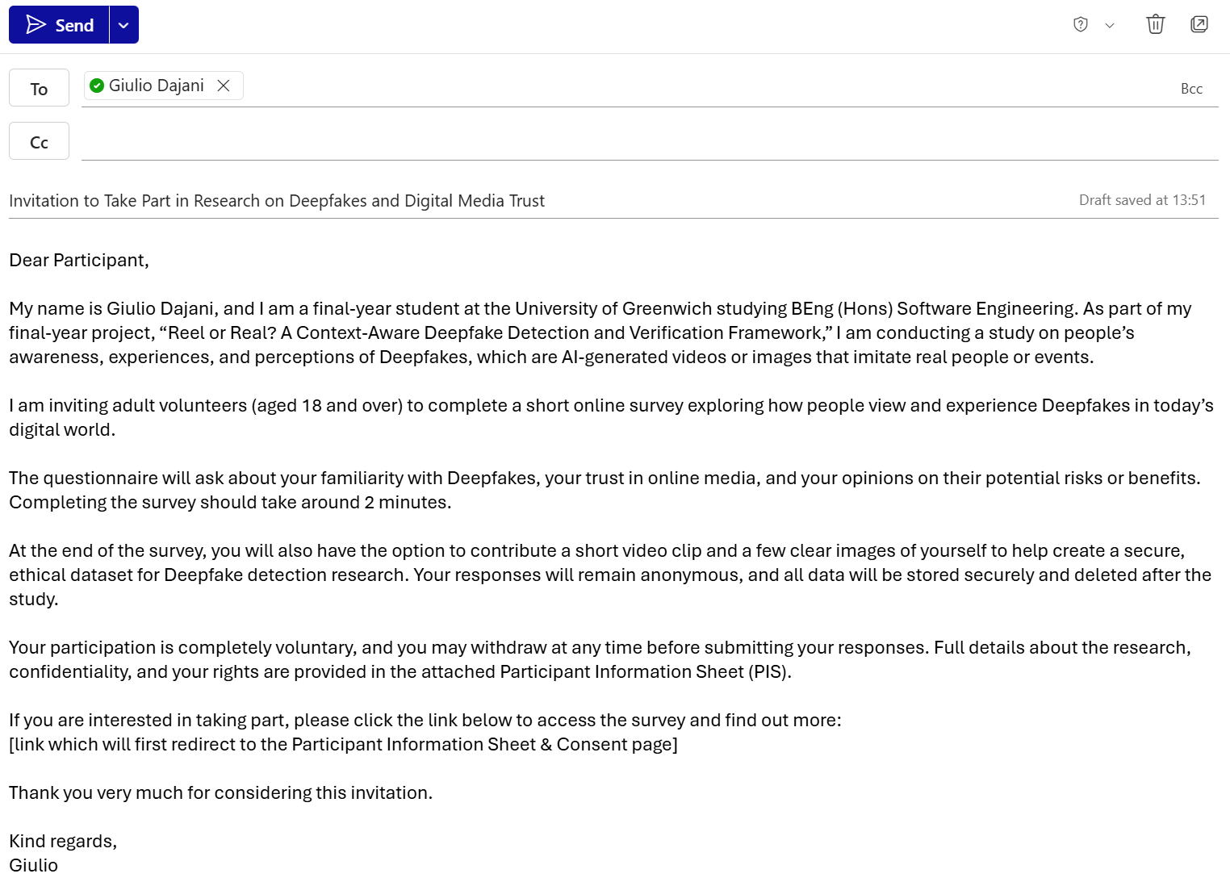

CONSENT TO PHOTOGRAPHY OR AUDIO/ VIDEO RECORDING & TRANSCRIPTION
(Participants over the age of 18)

Title of study: Reel or Real? A Context-Aware Deepfake Detection and Verification Framework
Investigator: Giulio Dajani
Supervisor: Razia Sulthana Abdul Kareem
This study involves photography/audio/video recording during data collection. Neither your name nor any other identifying information will be associated with the audio or audio/video recording. Only the research team will have access and be able to listen to and/or view the recordings. Recordings will be analysed by the researcher and erased once the study has been completed; all reported data will then be anonymised.
Images/videos may be reproduced in whole or in part for use in presentations or publications that result from this study. All identifying features (such as your face/distinctive physical markings) will be anonymised before use unless you explicitly give permission for full images to be used.
Participant consent
By signing this form, I am allowing the researcher to photograph/audio or videotape me as part of this research study. I understand that I have the right to request access and inspect or view the photographs/audio/video recordings or transcripts in the finished form that I may withdraw this consent at any time without penalty, at which point, the photograph/audio/videotape will be securely destroyed immediately and that copyright ownership remains with the University.
(Please tick one of the following)
o I consent for the researcher to use images/audio/video recordings for research-related publications in an anonymous format.
OR
o I consent for the researcher to use images/audio recordings for research-related publications and presentations that include my voice and/or images of my face/body.
Participant name: |  | Signature: |  | Date:
 | ^{(Block Capitals)}
Researcher name | GIULIO DAJANI | Signature: |  | Date: | 21/11/25
 | ^{(Block Capitals)}

Checklist:

Have you attached all relevant and mandatory documents? | YES
Have you filled in all mandatory sections? | YES
Has your application been discussed with your supervisor? | YES
Has your supervisor read and approved the application? | YES
Is the application being submitted as a single Word doc (no PDFs)? | YES
Has the application been submitted by the meeting submission deadline? | YES
Have you addressed the participants' right to withdraw and informed consent to participate? | YES
Has the Participant information sheet been filled in properly? | YES

